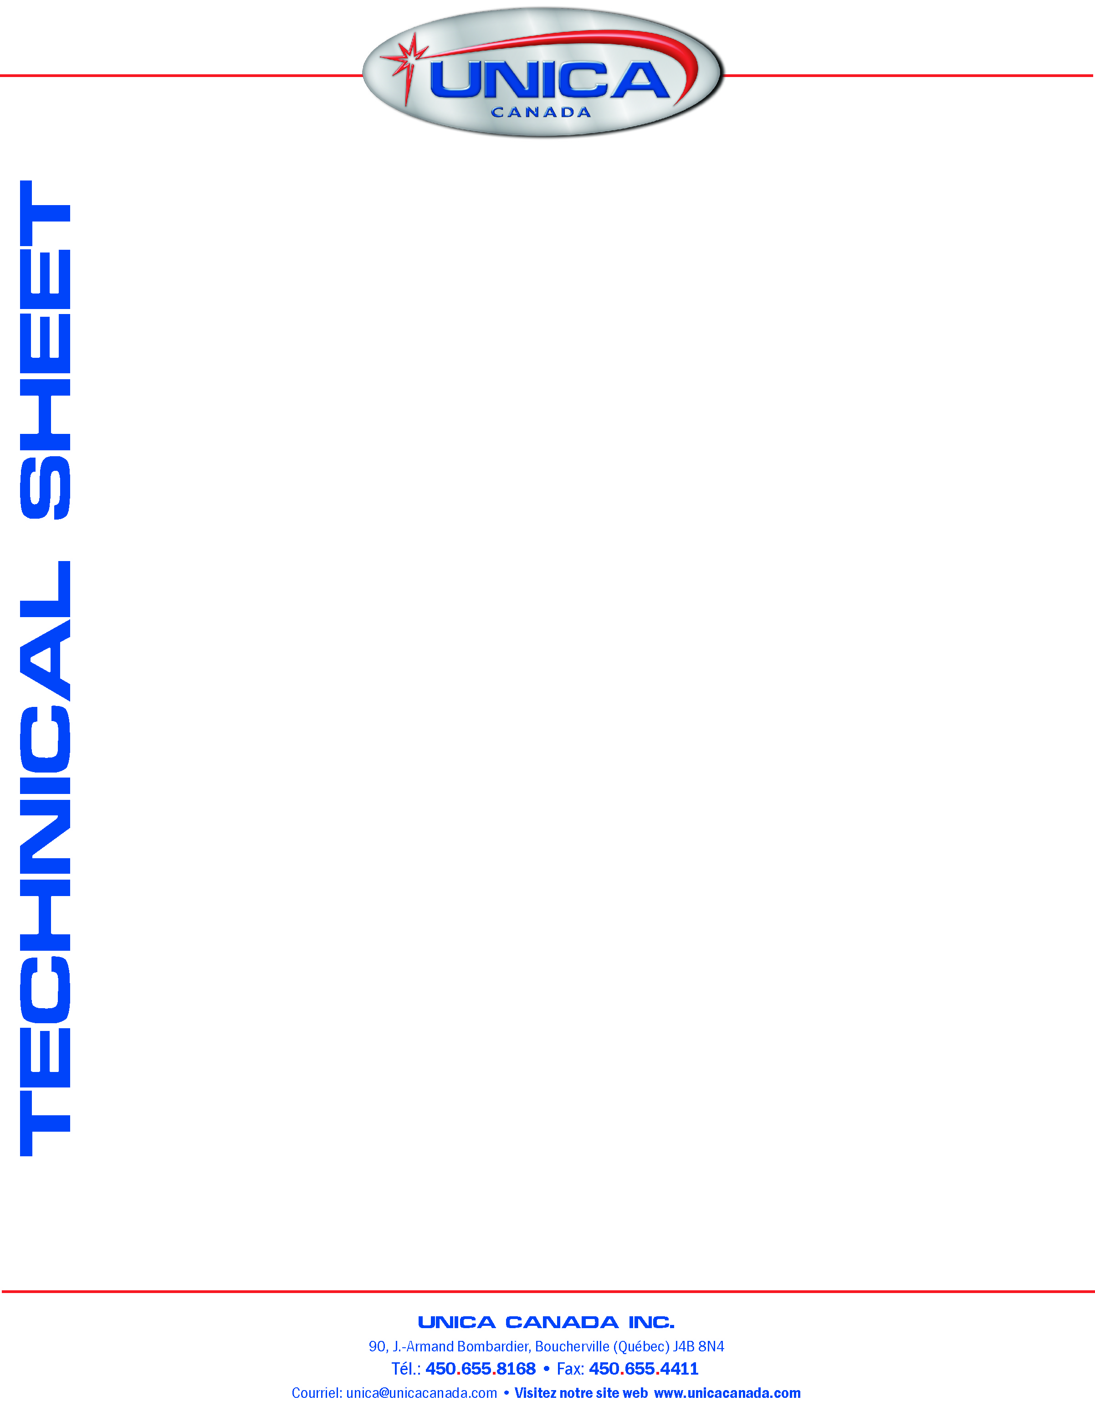
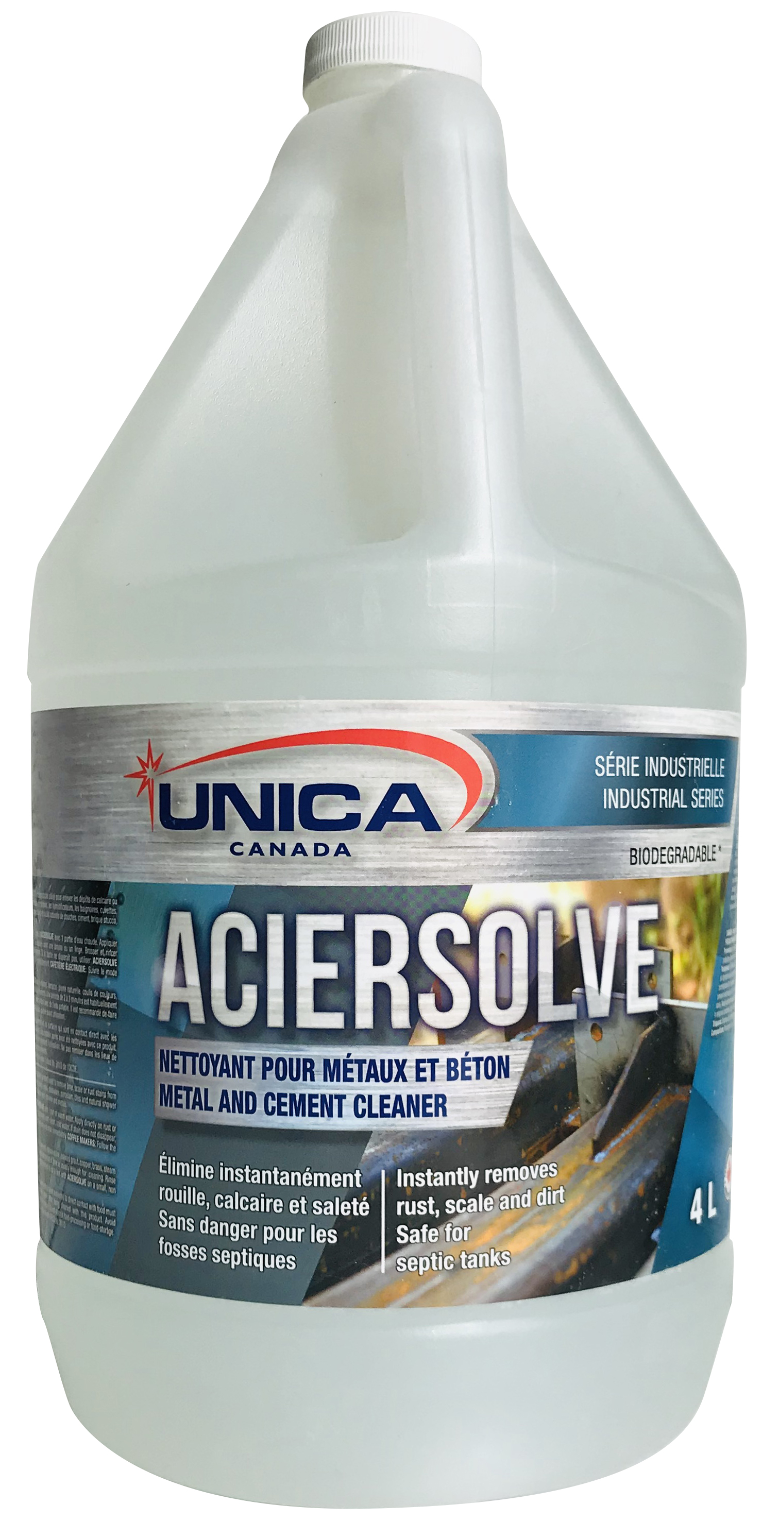
TECHNICAL DATA
pH (as is) 1.0
Density (20°C) 1.22 g/cc
Colour Clear
Fragrance None
Characteristic Corrosive
Biodegradability Complete
Flash Point More than 65°C
Freezing Stability Keep out from freezing
Degradability determined in accordance with OECD no. 301D.

DIRECTIONS
Mix 1-part ACIERSOLVE with 2 parts of warm water. Apply directly on rust or scale with a brush or cloth. Rinse promptly with clean cold water. If stain does not disappear, use ACIERSOLVE full strength, wipe and rinse immediately.
COFFEE MAKERS: Mix 1-part ACIERSOLVE with 15 parts of water. Run through coffee maker as if you were making coffee, rinse thoroughly by running 2 or 3 full pot of clean cold water through a complete cycle.
Never use ACIERSOLVE on marble, terrazzo, natural stone, coloured grout, copper, brass, steam irons wood, or clothing. A 2 to 3 minutes period of time is usually enough for the cleaning. Rinse promptly with cold water. It is recommended to do a test with ACIERSOLVE on a small, non-apparent area before using it. ACIERSOLVE is not harmful for shrub, but to help to prevent, always cover shrubs near from the work area. If ACIERSOLVE is in contact with a shrub, rinse thoroughly the shrub with potable water to neutralize the product. ACIERSOLVE is a powerful product, so when you clean metallic surfaces, ACIERSOLVE may remove shine on some metallic surfaces (stainless steel, aluminium, chrome). To give a new shine to metal, apply wax or clean the surfaces with a wax integrated product.
ACIERSOLVE
Metal & Cement Cleaner

DESCRIPTION
ACIERSOLVE is a 100% biodegradable product used to remove lime, scales or rust stains from coffee makers, humidifiers, tubs, toilets, skinks, on glassware, porcelain, tiles and natural shower grout, cement, brick, stucco, stainless steel, chrome and metals. It is also very good to clean oxidation deposits on aluminium, copper and battery terminals.
ADVANTAGES
1. Solvent to clean rust metallic dust 100% biodegradable.
2. Very powerful cleaner, ideal to clean aluminium, vinyl and tiles.
3. Easy to dissolve into hard or soft water, cold or hot.
4. Easily dissolve lime and scales.

