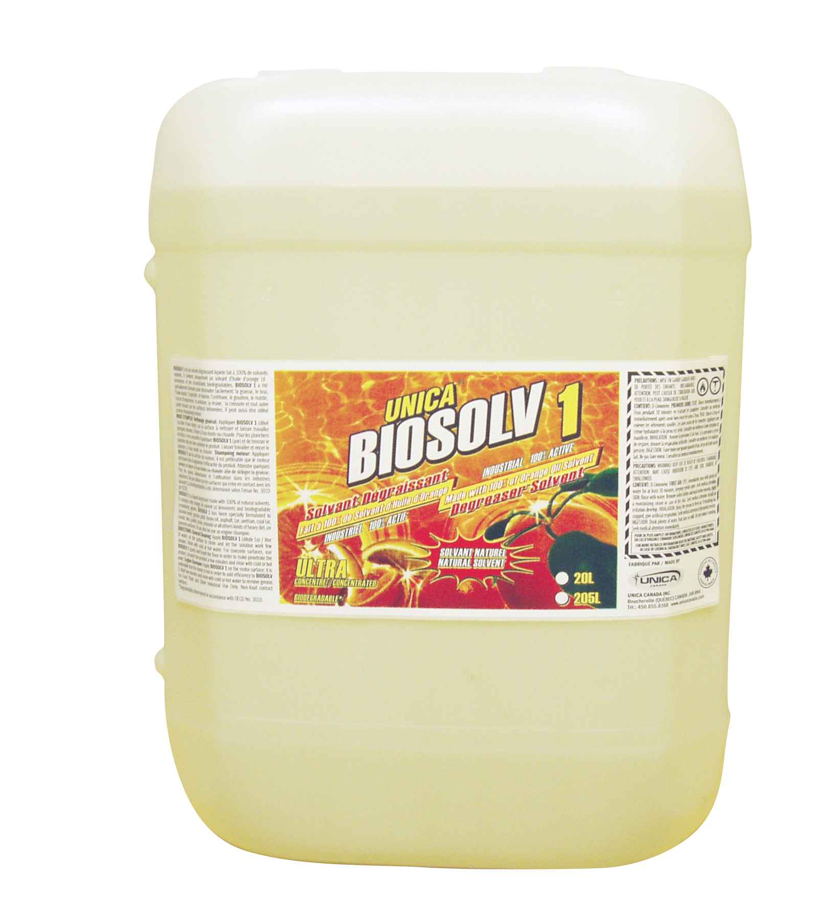
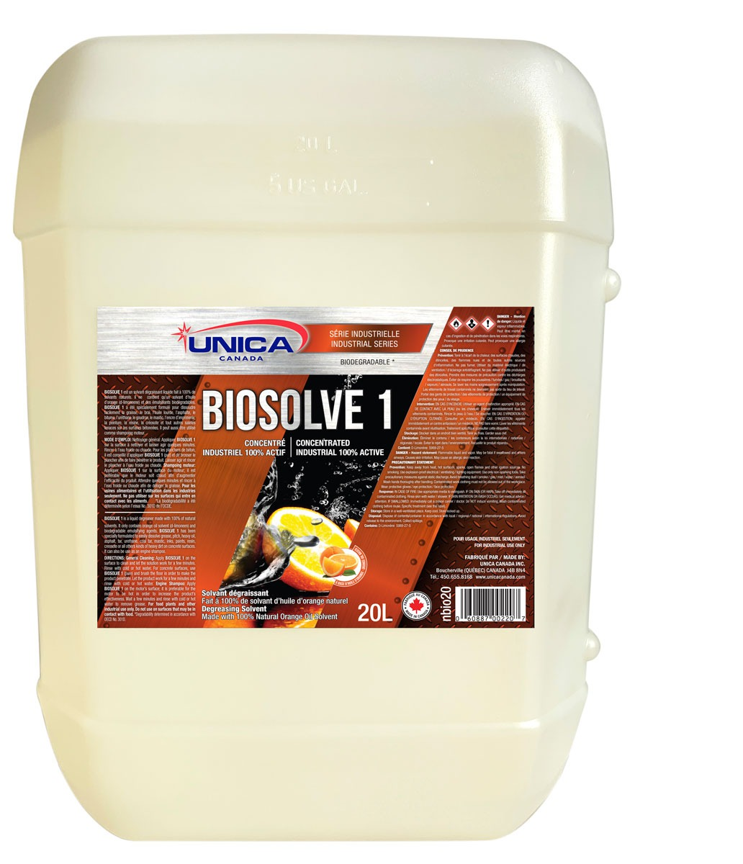
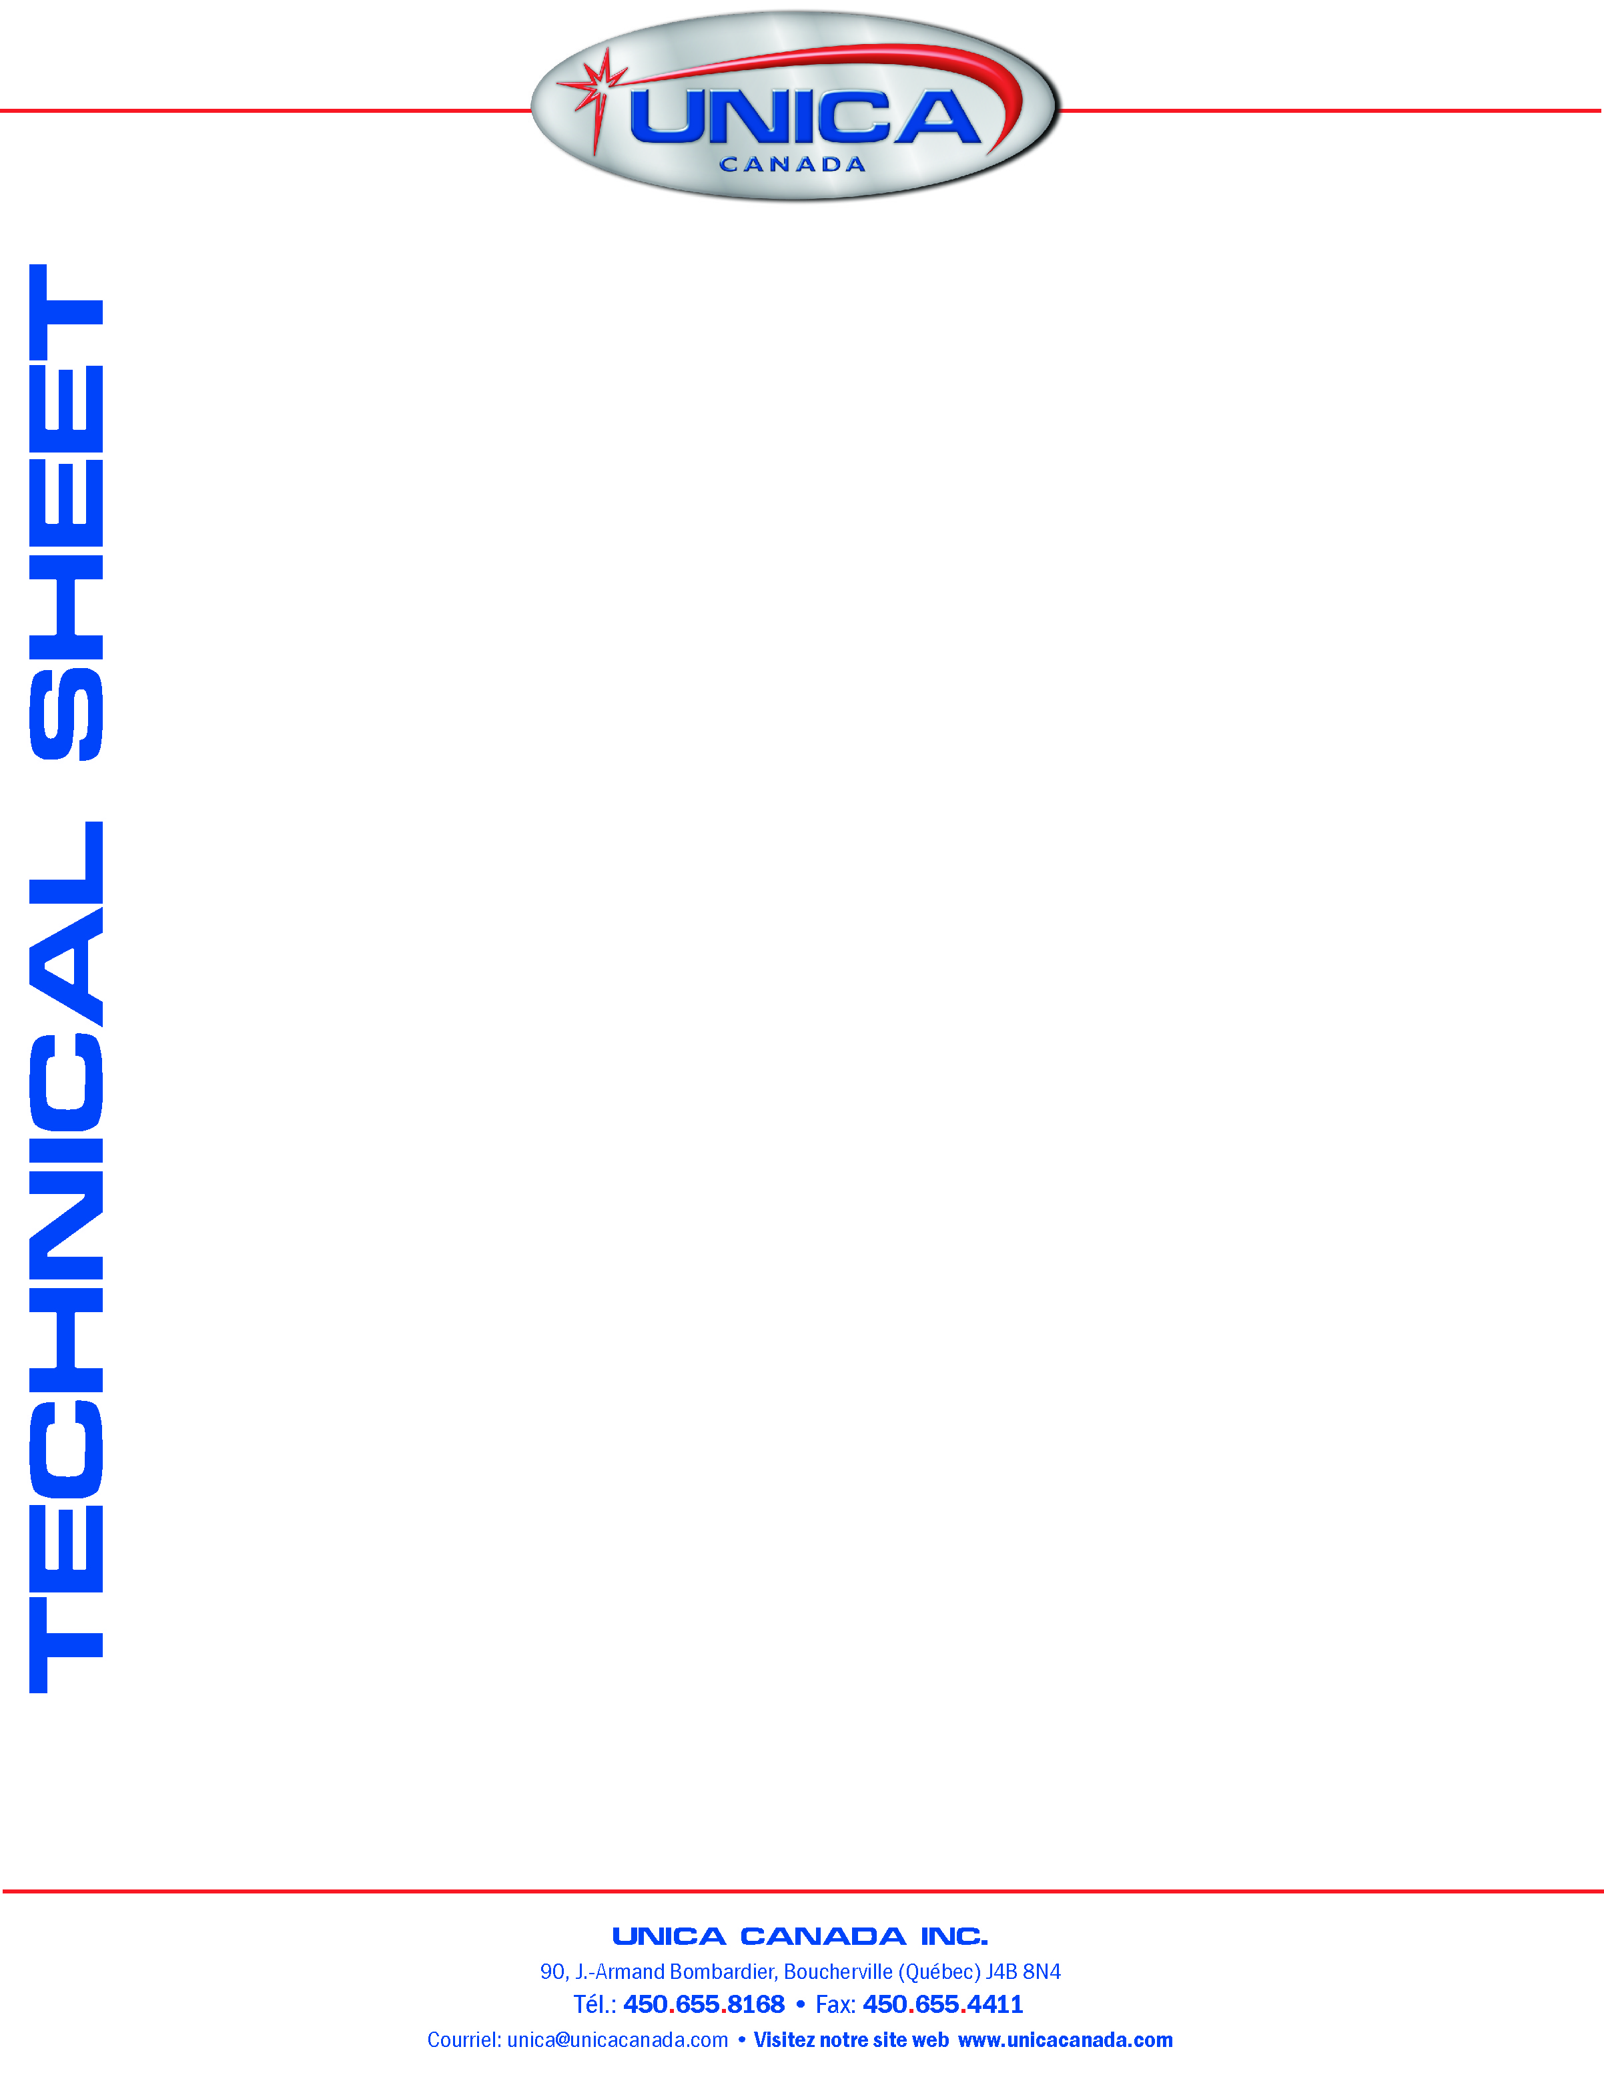
TECHNICAL DATA
pH (as is) 6.5 –7.0
Density (20°C) 0.82 – 0.86 g/cc
Colour Yellow
Fragrance Discrete citrus
Characteristic Flammable
Biodegradability Complete
Flash Point 53°C
Freezing Stability Stable
Degradability determined in accordance with OECD no. 301D.

DIRECTIONS
General Cleaning: Apply BIOSOLV 1 on the surface to clean and let the solution work few minutes. Rinse with cold or hot water. For concrete surfaces, use BIOSOLV 1 (pure) and brush the floor in order to make penetrate the product. Let work the product a few minutes and rinse with cold or hot water.
Engine Shampoo: Apply BIOSOLV 1 on the motor surface; it is preferable that the motor is hot in order to add efficiency to BIOSOLV 1. Wait few minutes and rinse with cold or hot water to remove grease.
BIOSOLV 1
Degreaser Solvent made with 100% of Orange Oil Solvent

DESCRIPTION
BIOSOLV 1 is a liquid degreaser made with 100% of natural solvents. It contains only orange oil solvent (d-limonene) and biodegradable emulsifying agents. BIOSOLV 1 has been specially formulated to dissolve easily: grease, pitch, heavy oil, asphalt, tar, urethane, coal tar, mastic, inks, paints, resin, creosote, or all other kinds of heavy dirt, on concrete surfaces. It can also be use as engine shampoo.

ADVANTAGES
1. Less toxic and mad e from biodegradable ingredients.
2. 100% active product doesn’t contain water.
3. Contains special additives and corrosion inhibitor to protect clean metal surfaces.
4. Very effective emulsifier for grease, turning white to ease the rinsing.
5. Non-corrosive
6. Best product to control bad odours and to clean viscous deposits.

